KafKa配置练习

1. 启动Kafka监听功能从哪里进行修改，改完的内容是什么









1. 启动单个kafak的命令是什么，如果判断kafka已经运行起来



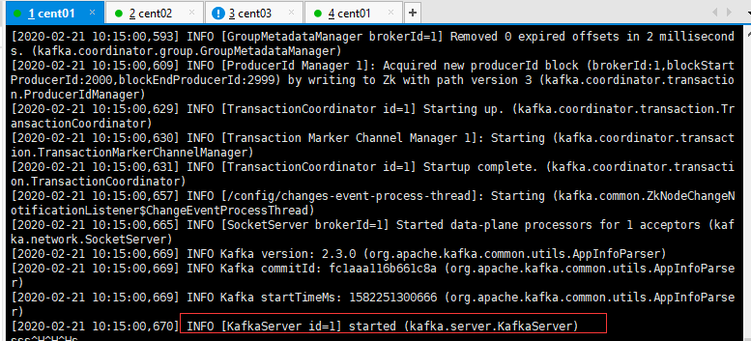

/usr/local/tool/zookeeper-3.4.13/bin/zkServer.sh start

/usr/local/tool/kafka_2.11-2.3.0/bin/kafka-server-start.sh /usr/local/tool/kafka_2.11-2.3.0/config/server.properties

/usr/local/tool/kafka_2.11-2.3.0/bin/kafka-server-stop.sh

rm -r -f /usr/local/tool/kafka_2.11-2.3.0/logs/kafka-logs

1. 集群kafka之间的主要区别，以及如何进行设置。

vi /usr/local/tool/kafka_2.11-2.3.0/config/server.properties













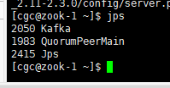

/usr/local/tool/kafka_2.11-2.3.0/bin/kafka-topics.sh --create --zookeeper 192.168.215.10:2181,192.168.215.20:2181,192.168.215.30:2181 --replication-factor 1 --partitions 1 --topic kafka01

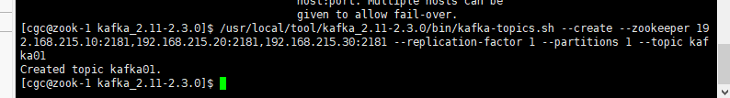

/usr/local/tool/kafka_2.11-2.3.0/bin/kafka-topics.sh --list --zookeeper 192.168.215.20:2181

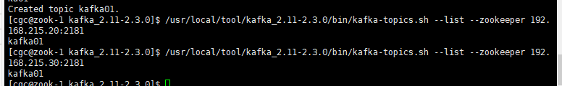

1. 生产者与消费者是符合区分的？如何进行交互？

/usr/local/tool/kafka_2.11-2.3.0/bin/kafka-console-producer.sh --broker-list 192.168.215.10:9092 --topic kafka01

/usr/local/tool/kafka_2.11-2.3.0/bin/kafka-console-consumer.sh --bootstrap-server 192.168.215.20:9092 --topic kafka01 --from-beginning

